**By:**

# Sona College of Technology

# Concept and Design Document

### Surya Narayanan CS Rithvikailas G Shurthika R

**Rubiga SA**

**Faculty Coordinator: Mr. Anand R**

### Department: ECE

**Theme: Health Care Management**

**Title: Mediband**

**MEDIBAND**

**(A MEDICAL SMARTBAND)**

#### Problem Statement:

Nowadays, unobserved human falls are been seen more often which is more dangerous. It causes major injuries health issues and sometimes even death.

Fall detection is a major challenge in the public healthcare domain, especially for the disability people and elderly as the decline of their physical fitness, and timely and reliable surveillance is necessary to mitigate the negative effects of falls.

#### Solution:

We have introduced an interesting compact easily wearable device "MEDIBAND" that monitors us throughout the day and if any accidental fall is been taking place it immediately intimates to the caretaker who is responsible. Our system features detection sensors which can able to detect between a normal fall and actual activity. A wearable device is placed on human’s wrist.

The system can detect the elderly’s falling by acceleration analysis. Then it will get the elderly’s geographic position and send fall alarm short message to caregivers. So, the elderly who has fallen can get timely help to minimize the negative influence.



#### Novelty:

* Our detection sensor will monitor the device for every 0.5s. So, the detection of fall will be more accurate and precise.
* Our device monitors the heart pulse rate of the user every 0.5s and if any abnormalities found in the heart pulse rate, it immediately intimates the care taker about it.
* Accelerometer sensor used in our device not only monitors the fall; if the speed limit crosses a certain limit, it indicates the person about the speed.
* Body temperature is one of the major factors that can be used to check the condition of a person. If the temperature of the person seems to be abnormal, it indicates their personal caretaker about the temperature.

Thus, this product will create a revolution in the society.

#### Objective:

Our system monitors the movements of human body, recognizes a fall from normal daily activities by an effective quaternion algorithm, and automatically sends request for help to the caregivers with the patient’s location.

**System Design:**

A wearable device is placed on human’s wrist. The system can detect the elderly’s falling by acceleration analysis. Then it will get the elderly’s

geographic position and send fall alarm short message to caregivers. So, the elderly who has fallen can get timely help to minimize the negative influence.

### Working of the Band:

During the time of fall, we all know that there will be change in acceleration abruptly and also change in gyro values that is vertical to horizontal. So based on these two parameters, MPU 6050 will sense the fall and trigger to the particular mobile number through IFTTT. The location of the victim is obtained by ESP8266 module. This feature might provide us with additional piece of mind. Getting help fast in these situations will be a lifesaving one.

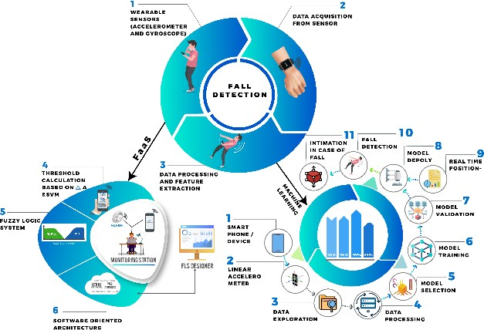

**Features:**

##### Accident prior detector:

We are using accelerometer sensor; we will be able to detect the emergency case in the field of major and minor accidents. If any sudden change in the gyro values been noticed, it automatically intimates the caretaker about the event.

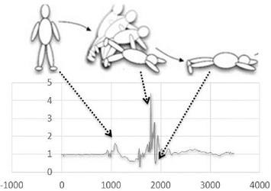

##### Temperature:

Body temperature is one of the major factors that can be used to check the condition of a person. If the temperature of the person seems to be abnormal, it indicates their personal caretaker about the temperature.

##### Women Safety:

Women safety is nowadays a highly compromised one. It is an irony that today’s modern society is not safe for women. When the user steps out her home, it starts the pulse sensor and switches on the mobile data in mobile. Whenever emergency is detected, the system works accordingly.

**Conclusion:**

All the given hypothesis has been fulfilled. This tech friendly device is super beneficial and helpful for everyone without any age criteria and doesn't have any exceptional cases related to working hours it's Whole working one.

Elders have immense experience through their life and they share their success and failures. It is important to note that causes of disability are usually determined by a person’s capability to perform activities of daily life. This idea was developed by our team for the concern about them.It's interesting and beneficial for all in this high-tech world.